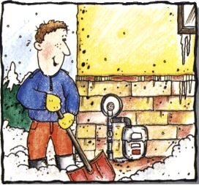
The City Council: The next City Council meeting will be on Wednesday, February 12th, 2020 at 6:15pm at City Hall.
IMPORTANT REMINDER: Please remember to clear snow and ice away from your gas meter. Winter is not over and the risk of causing damage to your meter is real. Remember to scoop around meter set carefully, you don’t want to harm the equipment while trying to protect it. Thank you for taking a few minutes to clear the ice and snow to save a lot in the long run.
2020 Dog License: Dog licenses are now due. They are $2.00 per dog and must be purchased at City Hall. If you need them and can’t make it into the office, please make out a separate check and provide info on which dog and the rabies shot information and put it in the mail slot on the front door of City Hall. We will get them to you with a receipt. Thanks!
2020 Electric Appliance Rebate: City Hall offers a rebate program for new electric appliances. To learn more, stop in and ask about the Energy Star conservation improvement program. Appliances must meet the criteria listed on the information sheets, available at City Hall. You will need to provide a copy of the receipt and yellow Energy Star sticker for the appliance.
Round Lake Fire Department: We are looking for community minded people who want to make a difference in our community. If you think being a fire fighter is something you would want to pursue, PLEASE stop in City Hall and grab an application. The City pays for all training, meetings and emergency calls. Volunteers needed!!!
Round Lake Sportsman Club: The wagon with corn by the elevator in Round Lake, is for anyone who has pheasants on their property and they want to help feed them during the winter months. If you want to put a feeder in your yard, send $10 donation to PO Box 67, Round Lake, MN 56167 and help yourself to one of the feeders located by the wagon. If there are none left, let a Round Lake Sportsman Club member know that you would like to have one by emailing, julie@rconnect.com.
Round Lake American Legion: The Round Lake American Legion Post 461 would like to announce plans to update the section of land located in the Round Lake Cemetery where the former veterans’ memorial was located. See letter included with this newsletter. Contact Larry Yeske at 507-945-8435, if you want more information.
Mark your calendars!!! Mark your calendars!!! Mark your calendars!!! Mark your calendars!!!
Round Lake American Legion: Pancake breakfast will be served on Sunday, February 2nd from 8:00am-noon! Pork chops will be served on Saturday, February 15th from 5:00-7:30pm or until gone. Call your order in and take it out by calling 507-945-8321. March Pancakes will be on Sunday, March 1st! No pork chops in March.
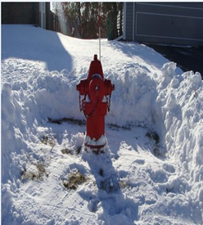
Remember to clear snow away from the fire hydrants near your property and there is no parking on the street when snow removal is needed.
Friday, February 14th is Valentine’s Day, remember your sweetheart!
City Hall will be CLOSED on Monday, February 17th, 2020 for President’s Day!

