Keep Gas Meters and Appliance Vents Clear of Snow and Ice
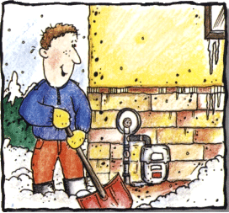
Homeowners are strongly encouraged to carefully clear snow from your natural gas meter and furnace vent.

Snow build-up can cause the meter or gas appliance, like a furnace or hot water heater, to malfunction. If a vent is blocked, carbon monoxide could build up in your home. A blocked vent could also cause a furnace or hot water heater to stop working.

Customers should use a broom or their hands to remove snow from a meter. Do not use a shovel because the hard tip could break the meter.

Newer furnaces and water heaters vent out the side of a home, instead of the top. Customers need to make sure sidewall vents and the roof top vents are clear of snow and ice.

Customers should also be aware of the dangers and risks of carbon monoxide (CO). The risk of illness or death from carbon monoxide increases in the winter. Every home or business should have at least one working CO monitor inside.
Important safety tips:
- Don’t pile snow on or near the meter when shoveling or using a snow blower
- Use your hands or a brush, not a shovel, to clear snow and ice from the meter
- Never bang on the meter or pipes
- Don’t let dripping water or freezing rain build up on the meter. The vent can become plugged when ice and snow melt during the day and refreeze at night
- Carefully remove icicles hanging above the meter
- Check furnace and water heater exhaust pipes. If an exhaust pipe is blocked, the furnace or water heater could malfunction or stop working

