The next City Council meeting will be on Wednesday, June 10th, 2020 at 6:15pm at the RL Senior Center.
Golf Cart Permits: Stop in City Hall to get your permits. Cost is $5.00 and it’s in our City Ordinance, need proof of insurance and a rearview mirror attached to golf cart. Any questions, call City Hall, 507-945-8127. Drivers MUST be at least 16 years of age to drive golf cart on city streets.
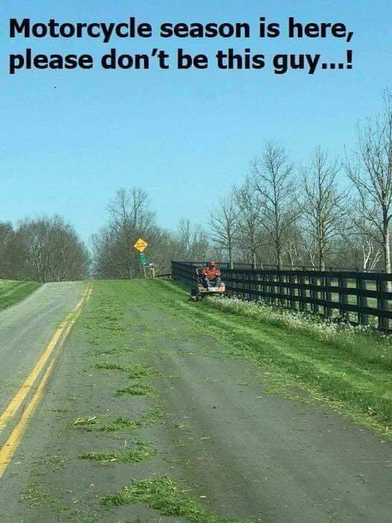
Lawns: Please make sure you are mowing your lawns REGULARLY!! The City does have an ordinance stating that grass and weeds are not to grow on any property to a height of more than six (6) inches. It also states that you are not to mow so that grass clippings go into the street. Please change direction of mowing so that clippings do not clutter the streets, they plug the storm drains and make the town look messy. As picture depicts, it’s dangerous for motorcycles! Makes the road as slick as ice in the winter.
Sump Pumps: Please take your sump pump hose OUT of the sewer and put it outside, if you haven’t already done so.
Minnesota Department of Health: There is a $9.72 charge on your utility bill this month. These funds are collected and are forwarded to the MDH, they use these funds to cover the expenses involved with the testing of public water systems in the state. Mandatory fee charged for each connection.
2020 Consumer Confidence Report: The complete version of the report is available in City Hall for you to review or if you would like a copy, please call City Hall during office hours to request a copy be mailed to you, 507-945-8127, this report is for the results of the 2019 Drinking Water testing.
Gopher One Call: Don’t forget to call 811 or 1-800-252-1166 BEFORE you dig, it’s the law, in Minnesota. If you are putting in a new garden, planting a tree or bush, or digging for any reason in your yard.
Mark your calendars!!! Mark your calendars!! Mark your calendars!!! Mark your calendars!!
Mosquito Spraying: A complete list of the dates they will be in Round Lake spraying is on the bulletin board located in the front window of City Hall for your convenience. You can see full schedule on our website, www.roundlk.net. June dates for spraying are the 4th, 15th & 25th.
RL/Brewster Girl Scouts: The scouts will be building a library box and installing it at the Round Lake city park. Location will be by the benches, in the northwest corner and it will contain adult and children books. More details to come. They need a volunteer to help build the box. If you are talented in this way and would like to offer your expertise, call Lyschel at 507-372-5291. Their carpenter fell through and they are not able to tackle this project without one. Thanks!
Round Lake American Legion Post #461 – Donations are still being accepted for the renovation of the Veteran’s Memorial out at the Round Lake Cemetery. Plans are ready and funding is the last piece of the project, that needs to be put into place, to meet their goal of $10,000. Donations can be sent to: American Legion Post 461, PO Box 81, Round Lake, MN 56167-0081. See flyer included in this mailing for details.
Drive-Up Food Distribution: Friday, June 5th from 11am-2pm at the Nobles County Fairgrounds. No appointment necessary, food available while supplies last. Produce, meat and dairy products will be given out.
Greater Round Lake Community Association: See flyer included in this mailing. Lots of activities going on!
Red Cross Blood Mobile: Save the date!!! Monday, July 13th, 2020 the blood mobile will be in Round Lake!
City Cleanup this year will be September 22, 2020. Mark your calendar and keep junk inside or neatly stacked in your yard, but don’t put it on the curb until September!!! Postponed due to COVID-19 regulations. Remodeling this year? Rent a dumpster! Size of pile will be limited to a pickup box this year, extra fees will be added if you have more.

