The next City Council meeting will be on Wednesday, June 9th, 2021 at 6:30pm at City Hall.
Golf Cart Permits: Stop in City Hall to get your permits. Cost is $5.00 and it’s in our City Ordinance, need proof of insurance and a rearview mirror attached to golf cart. Any questions, call City Hall, 507-945-8127. Drivers MUST be at least 16 years of age to drive golf cart on city streets.
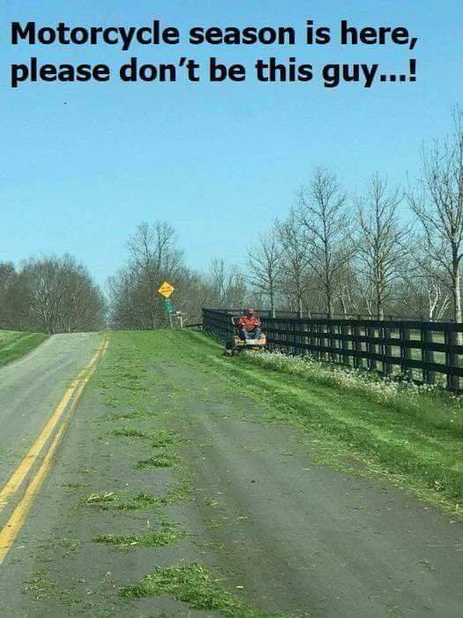
Lawns: Please make sure you are mowing your lawns REGULARLY!! The City does have an ordinance stating that grass and weeds are not to grow on any property to a height of more than six (6) inches. It also states that you are not to mow so that grass clippings go into the street. Please change direction of mowing so that clippings do not clutter the streets, they plug the storm drains and make the town look messy. As picture depicts, it’s dangerous for motorcycles! Makes the road as slick as ice in the winter.
Sump Pumps: Please take your sump pump hose OUT of the sewer and put it outside, if you haven’t already done so.
Minnesota Department of Health: There is a $9.72 charge on your utility bill this month. These funds are collected and are forwarded to the MDH, they use these funds to cover the expenses involved with the testing of public water systems in the state. Mandatory fee charged for each connection.
2021 Consumer Confidence Report: The complete version of the report is available in City Hall for you to review or if you would like a copy, please call City Hall during office hours to request a copy be mailed to you, 507-945-8127, this report is for the results of the 2020 Drinking Water testing.
Gopher One Call: Don’t forget to call 811 or 1-800-252-1166 BEFORE you dig, it’s the law, in Minnesota. If you are putting in a new garden, planting a tree or bush, or digging for any reason in your yard.
Mark your calendars!!! Mark your calendars!! Mark your calendars!!!
Mosquito Spraying: A complete list of the dates they will be in Round Lake spraying is on the bulletin board located in the front window of City Hall for your convenience. You can see full schedule on our website, www.roundlk.net. June dates for spraying are the 3rd, 14th, & 24th.
Round Lake American Legion Post #461: The Round Lake Legion will be having their pork chop dinner on Saturday, June 19th, 2021. Dine-in is available, but take out is also an option for an additional $.50. Call 945-8321 to order yours ahead or for take-out.
Southwest MN Broadband Services: Does your internet connection need a boost? With construction season upon us, SMBS is now offering low cost or in most cases, NO cost rates to bury fiber optic lines to unserved homes & businesses throughout the community, please call 507-945-0010 for more information.

Round Lake Fire Department: The Round Lake Fire Department will be having their OPEN HOUSE at the Fire Hall on Sunday, June 6th, 2021 from 3:00-5:00pm. Lunch will be served with demonstrations at 4:00pm and the drawing for prizes at 4:30pm.

