The next City Council meeting will be on Tuesday, June 14th, 2022 at 6:30pm at City Hall.
Golf Cart Permits: Stop in City Hall to get your permits. Cost is $5.00 and it’s in our City Ordinance, need proof of insurance and a rearview mirror attached to golf cart. Any questions, call City Hall, 507-945-8127. Drivers MUST be at least 16 years of age to drive golf cart on city streets.
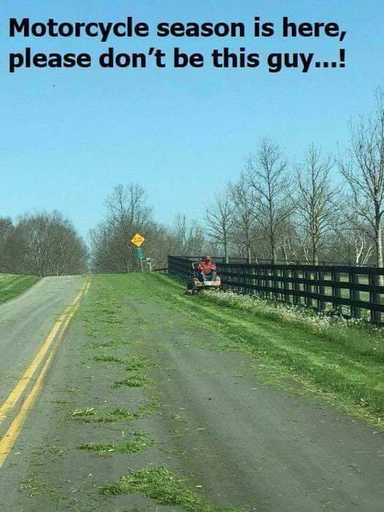
Lawns: Please make sure you are mowing your lawns REGULARLY!! The City does have an ordinance stating that grass and weeds are not to grow on any property to a height of more than six (6) inches. It also states that you are not to mow so that grass clippings go into the street. Please change direction of mowing so that clippings do not clutter the streets, they plug the storm drains and make the town look messy. As picture depicts, it’s dangerous for motorcycles! Makes the road as slick as ice in the winter.
Sump Pumps: Please take your sump pump hose OUT of the sewer and put it outside, if you haven’t already done so.
Minnesota Department of Health: There is a $9.72 charge on your utility bill this month. These funds are collected and are forwarded to the MDH, they use these funds to cover the expenses involved with the testing of public water systems in the state. Mandatory fee charged for each connection.
2022 Consumer Confidence Report: The complete version of the report is available in City Hall for you to review or if you would like a copy, please call City Hall during office hours to request a copy be mailed to you, 507-945-8127, this report is for the results of the 2021 Drinking Water testing.
Gopher One Call: Don’t forget to call 811 or 1-800-252-1166 BEFORE you dig, it’s the law, in Minnesota. If you are putting in a new garden, planting a tree or bush, or digging for any reason in your yard. Pounding stakes into the ground for a fence or mailbox is also something to call 811 for. You never know what is buried in your yard!!! CALL BEFORE YOU DIG!!!! Any damage you cause will be your responsibility to repair.
Mark your calendars!!! Mark your calendars!! Mark your calendars!!!
Mosquito Spraying: A complete list of the dates they will be in Round Lake spraying is on the bulletin board located in the front window of City Hall for your convenience. You can see full schedule on our website, www.roundlk.net. June dates for spraying are the 2nd, 9th, 23rd, 30th.
Round Lake American Legion Post #461: The Round Lake Legion will be having their pork chop dinner on Saturday, June 18th, 2022. Dine-in is available, but take out is also an option for an additional $.50. Call 945-8321 to order yours ahead or for take-out.
Round Lake Fire Department: The Round Lake Fire Department would like to thank all of you that came out for the Open House and for your continued support through donations this year. It is an honor to volunteer for our community and we appreciate your support. Congratulations to all who won prizes.
Round Lake Brewster School District 2907: Will hold public meetings for a School Bond Referendum Election on
June 8th, June 22nd, and August 1st, 2022, at 7:00pm to share information addressing facility issues, needs, and improvements. On June 8th, and August 1st, tours of the building will be given. Please attend to learn information and to answer any questions that you may have.
June 8th, 2022: RLB School Gymnasium at 7:00pm - Brewster
June 22nd, 2022: City of Round Lake in the City Hall Meeting Room at 7:00pm – Round Lake
August 1st, 2022: RLB School Gymnasium at 7:00pm - Brewster
Thank you for your support of Round Lake Brewster Schools.

JULY Sneak Peak: RL Fire Department Fundraiser July 9th all vehicles welcome & Red Cross Bloodmobile July 11th! Look for more details in next month’s newsletter.

