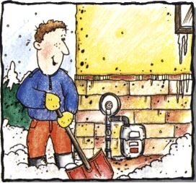
The City Council: The next City Council meeting will be on Wednesday, February 8th, 2023 at 6:30pm at City Hall.
IMPORTANT REMINDER: Please remember to clear snow and ice away from your gas meter. Winter is not over and the risk of causing damage to your meter is real. Remember to scoop around meter set carefully, you don’t want to harm the equipment while trying to protect it.

2023 Dog License: Dog licenses are now due. They are $2.00 per dog and must be purchased at City Hall. If you need them and can’t make it into the office, please make out a separate check and provide info on which dog and the rabies shot information and put it in the mail slot on the front door of City Hall. We will get them to you with a receipt. Thanks!
2023 ELECTRIC Appliance Rebate: City Hall offers a rebate program for new ELECTRIC appliances. To learn more, stop in and ask about the Energy Star conservation improvement program. Appliances must meet the criteria listed on the information sheets, see the enclosed green flyer, they are also available at City Hall. You will need to provide a copy of the receipt and yellow Energy Star sticker for the appliance.
Round Lake Fire Department: We are looking for community minded people who want to make a difference in our community. If you think being a fire fighter is something you would want to pursue, PLEASE stop in City Hall and grab an application. The City pays for all training, meetings and emergency calls. Volunteers needed!!!
Round Lake Sportsman Club: The wagon with corn by the elevator in Round Lake, is for anyone who has pheasants on their property and they want to help feed them during the winter months. If you want to put a feeder in your yard, send $10 donation to PO Box 67, Round Lake, MN 56167 and help yourself to one of the feeders located by the wagon. If there are none left, let a Round Lake Sportsman Club member know that you would like to have one by emailing, julie@rconnect.com.
Mark your calendars!!! Mark your calendars!!! Mark your calendars!!! Mark your calendars!!!
Round Lake American Legion: Pancake breakfast will be served on Sunday, February 5th from 8:00am-noon! Pork chops will be served on Saturday, February 18th from 5:00-7:30pm or until gone, watch City Hall sign located on Main Street for details. Call your order in and take it out by calling 507-945-8321. The public is welcome! The American Legion is open for the public most weekends, stop in, have a beverage and support a local non-profit. March Pancakes will be on Sunday, March 5th! Pork chops in March will be served on Saturday, March 18th.
Remember to clear snow away from the fire hydrants near your property and there is no parking on the street when snow removal is needed.
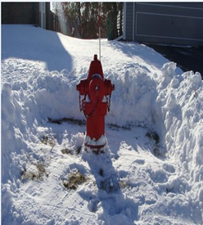
Tuesday, February 14th - is Valentine’s Day, remember your sweetheart!
Voting on the school referendum question will be at City Hall from 3-8pm only!! Stop in and cast your vote, community involvement is essential!!!

City Hall will be CLOSED on Monday, February 20th, 2023 for President’s Day!

Clear the snow around the mailboxes, if you don’t, the mailman has a tough time reaching the boxes and if it’s too hard to get to them, he will not deliver the mail. Help him out and have the snow cleared away!
The Greater Round Lake Community Center: February 17th, 18th & 19th plan to see The Hallelujah Girls at The Greater Round Lake Community Center. Tickets available at the door. All shows included pop & popcorn for $15/ticket. See the back of this page for more info.

AARP Tax Prep – If you are interested in help filing your taxes, call 507-370-1421 to make an appointment. Beginning February 6th, by appointment only, on Monday and Thursday from 9:00am to 12:30pm. Last day will be April 13th, 2023. No income guidelines for this program and there are some returns that don’t may not be able to be done, such as self-employment and more complex returns.

