Meals on Wheels: Meals on Wheels delivers in Round Lake. If you are interested in receiving meal delivery, please call Brenda Groenwald at 507-376-9718 for more information. Please share this info with your neighbors or anyone you think may be interested. If you are interested in being a driver, please call City Hall 507-945-8127. Meals are delivered Monday through Friday and they arrive between 11:00-11:45am.

Recycle Shed & City Hall dumpsters: There is a red and white shed behind the former bank building, this is for Round Lake and Nobles Co townships residents, to put larger CARDBOARD & OTHER items for recycling pickup only. If you have filled your container and just have extra recyclables that aren’t cardboard, they can go in the green containers at City Hall. (Keep in mind, it is illegal to use another person’s dumpster without their permission.) The dumpsters by the bank are privately rented dumpsters, please do not use them, unless you are paying the bill to have them. Thank you! * If you are doing a remodel, please pay for your own dumpster, DO NOT fill City Hall’s dumpster with construction materials. Thank you. *

Pop Can Wagon: The Boy Scouts are putting the wagon in storage for the winter. Please save those cans for spring, they will put the wagon back out for donations in Spring of 2024. Thank you!

Colder Weather: The temperatures are going down, now is a good time to make sure your furnace is running properly. Stay warm and have a safe heating season, get your furnace checked and replace those filters.

Winter Parking Policy: When the snow starts falling, move your vehicles/trailers, etc. OFF the road. The City will have anything on the street towed, if it is on the street and they need to do snow removal. This policy is for the safety of our crew and the residents of Round Lake, some of the streets are not wide enough to move snow when there are vehicles on the road. Help us make our city a safe and clean place to live.

Round Lake Natural Gas: See enclosed Scratch & Sniff pamphlet for important natural gas safety information.

Welcome Signs for edges of town: Do you have a good idea for the design of the Welcome to Round Lake signs? Submit ideas to City Hall for a chance to win a prize, if your design is chosen to make the new Welcome to Round Lake signs. Draw out the design and make sure you put your name on the back. Submissions will be accepted until February 29, 2024. Construction on the new signs will begin in the spring, weather permitting.

Calling all parents: Do you have children ages 0-4 years old? If you answered yes, please call the Round Lake-Brewster School to make sure your child is on the census. We use the census to contact parents to let them know of educational opportunities through the school like ECFE, Preschool and Early Childhood Screening. You may call the school at 507-842-5951. (Please include Child’s name, Birthdate, Parents names, address, and phone number if you leave a message.) Thanks, we look forward to hearing from you!

Mark Your Calendars!! Mark Your Calendars!! Mark Your Calendars!! Mark Your Calendars!!

Round Lake Legion Happy Hour: The Round Lake Legion is offering $1.00 off drinks from 5:30-6:30pm every Friday! Come out and enjoy some quality time with others from the community and get a bargain!

RL American Legion: There will be pancakes served at the Legion on November 5th from 8:00am-Noon! The pancakes are second to none and the men do all the cooking! Can’t beat the price anywhere for good food and great service. Plan to have breakfast at the Legion on November 5th, you will not be disappointed! Next one will be on Sunday, December 3rd ** Please note – No Pork Chop dinner in November or December**

City Council Meeting: The next City Council meeting will be held on Wednesday, November 8th 2023, at 6:30pm at City Hall.

Veterans’ Day: City Hall will be CLOSED on Friday, November 10th in observance of Veterans’ Day.
Red Cross Bloodmobile: Someone in the U.S. needs blood every two seconds! The blood supply can only come from volunteer blood donors. A Red Cross Bloodmobile will be at the American Legion in Brewster from 1:00 PM - 6:00 PM on Monday, November 13, 2023. Go to redcrossblood.org for more information or to make an appointment.
Thanksgiving Week: City Hall will be CLOSED on Thursday, November 23rd & Friday, November 24th for the Thanksgiving Day holiday. Happy Thanksgiving to you all!

Daylight Savings Time ends on Sunday, November 5th, 2023. Do not forget to change your clocks back one hour the night before! Remember to Fall Back! This is the best time of year to change all the batteries in your smoke detectors, also!

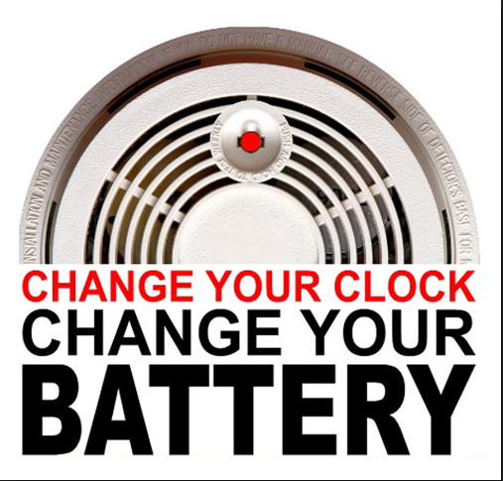

See other important flyers included this month in your bill mailing.

