The City Council: The next City Council meeting will be on Wednesday, January 10th, 2024 at 6:30pm at City Hall.

Dog License: 2024 dog licenses are due! Please stop down to City Hall and pay the $2.00 per dog to satisfy your responsibility as part of the Round Lake community. It’s in our ordinances that all dogs need to be licensed and on a LEASH AT ALL TIMES!!!! Thank you. You will need to show proof of rabies shots for all dogs that you buy a license for, I can make a copy of your info at City Hall. PLEASE remember to pick up after your dog when taking them for a walk and they do their business. Respect others in the community by taking care of your animal. Thanks! We have lots of complaints about dogs running loose, make sure they are secure!

REMINDER! Snow Season: City ordinance states “no vehicles or other items are to be parked on the street during snowfall, until AFTER snow removal is done.” PLEASE honor this ordinance! Having vehicles parked on the street makes it dangerous for the plow drivers and risks damage to your vehicles. Vehicles that remain on the street will be towed at owner’s expense. Thank you in advance! Do NOT push or blow snow onto your neighbor’s property, it is disrespectful and they don’t appreciate it. City Ordinance states that you are not to blow snow into City streets, either. Clear snow around mailboxes to make it easier to deliver the mail, we all need to work together to make the winter months better for all of us! That is if we ever get snow!!

Natural Gas Customers: If you are planning to install a standby generator for power outages, you MUST CONTACT CITY HALL BEFORE YOU INSTALL IT!!!! There are special requirements that must be met for these generators and you may need a different meter as well. Call Derek at City Hall, if you are planning to install a standby generator! 507-945-8127 ***See additional winter safety notice on the back of this newsletter!

Water Lines Inventory: Please read the letter mailed out by the City of Round Lake and take pictures of your water lines where they enter your house and the meter. We need to do an inventory of every water line in town for state required reporting. If you need help taking these pictures, call City Hall to make an appointment. 507-945-8127 We need rentals and homeowners to respond to this request. Thank you!

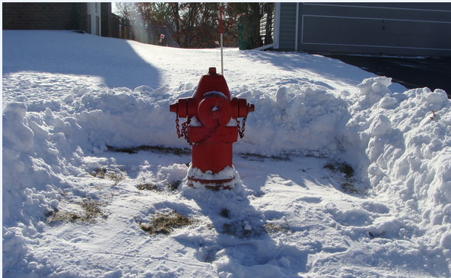
If you have one of these near your house, please dig it out! Help the City keep hydrants free of snow during the winter months. In an emergency, you will be glad you did!
HAPPY NEW YEAR! HAPPY NEW YEAR!
Big THANK YOU to those attended the Community Christmas Breakfast. And to the First Presbyterian Church Concerned Christians Committee for helping those in need this Christmas season.

Round Lake American Legion: There will be pancakes served on Sunday, January 7th from 8:00am – Noon. Mark your calendars and come have a great breakfast! Everyone is welcome, you don’t have to be a legion member to attend!!

City Hall: City Hall was CLOSED for New Year’s Day, Monday, January 1st, 2024.
City Hall: City Hall will be CLOSED for Martin Luther King, Jr Day on Monday, January 15th, 2024!

Red Cross Bloodmobile: Monday, January 15th from 2:00-7:00pm a Red Cross Bloodmobile will be at the Round Lake American Legion. Appointment sign-up and additional information can be found online at www.redcrossblood.org or call Lynn at 507-945-8122. New donors are welcome and encouraged! Your donation could make a great difference in someone’s life!

