The next City Council meeting will be on Wednesday, June 11th, 2025 at 6:30pm at City Hall.
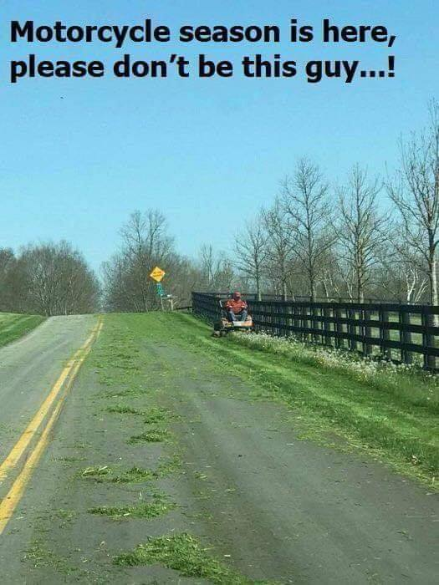
Lawns: Please make sure you are mowing your lawns REGULARLY!! The City does have an ordinance stating that grass and weeds are not to grow on any property to a height of more than six (6) inches. It also states that you are not to mow so that grass clippings go into the street. Please change direction of mowing so that clippings do not clutter the streets, they plug the storm drains and make the town look messy. As picture depicts, it is dangerous for motorcycles! Makes the road as slick as ice in the winter.
Sump Pumps: Please take your sump pump hose OUT of the sewer and put it outside, if you have not already done so.
Minnesota Department of Health: There is a $9.72 charge on your utility bill this month. These funds are collected and are forwarded to the MDH, they use these funds to cover the expenses involved with the testing of public water systems in the state. Mandatory fee charged for each connection.
ATTENTION DOG OWNERS! – Round Lake requires all dogs to be on a leash or tie out when outside of your house. We have gotten multiple reports of dogs running loose and people are scared to walk around town because of dogs approaching them on the street. If you take your dog for a walk, it is also your responsibility to clean up after them. Kids play in the park and we do not want them to have to deal with your dog’s poop! Be considerate of others!
2025 Consumer Confidence Report: The complete version of the report is available in City Hall for you to review or if you would like a copy, please call City Hall during office hours to request a copy be mailed to you, 507-945-8127, this report is for the results of the 2023 Drinking Water testing.
Gopher One Call: Don’t forget to call 811 or 1-800-252-1166 BEFORE you dig, it’s the law, in Minnesota. If you are putting in a new garden, planting a tree or bush, or digging for any reason in your yard. Pounding stakes into the ground for a fence or mailbox is also something to call 811 for. You never know what is buried in your yard!!! CALL BEFORE YOU DIG!!!! Any damage you cause will be your financial responsibility to repair. See brochure for more details. See the back of this page for important notice from Round Lake Gas Municipal Gas.
Mosquito Spraying: A complete list of the dates they will be in Round Lake spraying is on the bulletin board located in the front window of City Hall for your convenience. You can see full schedule on our website, www.roundlk.net. June dates for spraying are the 5th, 19th, 26th, and July 10th, & 24th.
Round Lake American Legion Post #461: The Round Lake Legion will be having their pork chop dinner on Saturday, June 21st, 2025. Dine-in is available, but take out is also an option for an additional $.50. Call 507-945-8321 to order yours ahead or for take-out.
Round Lake Fire Department: The Round Lake Fire Department will be having their weekend of fun, August 1st – 3rd, 2025. Hope everyone can get out and enjoy the fun! Consider joining the department, if that is something you have wanted to do. Round Lake Fire Dept is always looking for new members!
The U & I Garden Club of Round Lake: Will be hosting the MN State Horticulture Society’s District 4 69th Annual Flower Show and meeting on June 10th at the Round Lake Community Center located at 445 Harrison Street in Round Lake, MN. Flower Show entries will be taken from 8-9:30am with judging to begin after that and will be done by 11:30am. Anyone wishing to take part in the flower show should contact Amy Bah 507-945-0016. Morning coffee will be served during that time with the meeting starting at 9:45am and the first speaker is scheduled at 10:30am. Lunch will be served from 11:45-12:30pm. The second speaker will start at 12:30pm.
There will be local garden vendors with plants and other garden items for sale. There will also be plants brought in for sale from the district’s gardeners. Registration is $12.00 and $13.00 for food & beverages for the day. To register, please contact Sandy Consoer 507-945-8306.
City Hall will be CLOSED on June 19th, 2025 in observance of the holiday.

